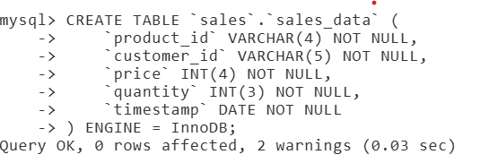

Import data

listtables

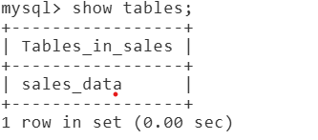

Sales rows

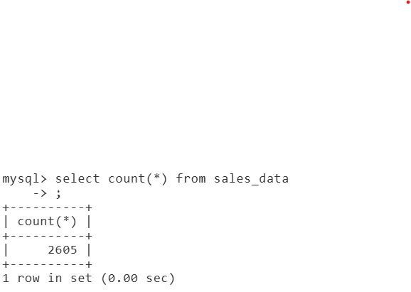

Listindexes

Shell script to import data

